Bima Kwik Insurance Platform System Architecture Document

Table of Contents

Introduction
- Purpose of Document
- Scope
- Audience

System Overview
- Brief Description
- Key Features
- User Types

Architectural Design
- High-Level Architecture
- Microservices and Components
- Data Flow Diagram

User Roles and Responsibilities
- Sales Agent
- Admin
- Insurance Companies
- TIRA (Tanzania Insurance Regulatory Authority)

Data Management
- Database Architecture
- Data Models
- TIRA Integration

Security and Authentication
- User Authentication and Authorization
- Encryption and Data Security
- Role-Based Access Control

Payment Integration
- Selcom Integration
- Payment Processing Flow

User Interfaces
- Mobile App
- WhatsApp Bot
- Admin Dashboard

Business Logic and Processing
- Sales Process
- Claims Handling
- Package Management

System Integration
- API Communication
- Integration with Insurance Companies
- TIRA Integration

Regulatory Compliance
- TIRA Interaction
- Policy Posting and Audit

Scalability and Performance
- Load Balancing
- Caching Strategies
- Monitoring and Optimization

Deployment and Infrastructure
- Cloud Hosting
- DevOps Practices

Future Enhancements
- Potential Features
- Scalability Planning

Conclusion

1. Introduction

1.1 Purpose of Document
This document aims to provide a comprehensive overview of the system architecture for the Bima Kwik Insurance Platform, including its components, interactions, and design principles.

1.2 Scope
The scope includes the entire architecture of the Bima Kwik Insurance Platform, covering modules, user roles, data flow, integrations, security measures, and scalability strategies.

1.3 Audience
This document is intended for technical stakeholders, developers, architects, project managers, and those involved in the design, development, or maintenance of the Bima Kwik Insurance Platform.

2. System Overview

2.1 Brief Description
The Bima Kwik Insurance Platform provides users in Tanzania with a seamless way to purchase insurance policies, including a robust mobile money payment integration through Selcom.

2.2 Key Features
User-Centric Interface: The platform offers an intuitive mobile app and WhatsApp bot for user interactions and insurance purchases.
Admin Dashboard: A comprehensive dashboard empowers administrators to monitor transactions and manage platform activities.
Insurance Company Collaboration: Insurance companies can manage agents, claims, and packages through dedicated interfaces.
Regulatory Compliance: Integration with the Tanzania Insurance Regulatory Authority (TIRA) ensures compliance with local insurance regulations.

2.3 User Types
Sales Agent: Engages users through the mobile app and WhatsApp bot to facilitate insurance sales.
Admin: Oversees platform operations and transactions via the admin dashboard.
Insurance Companies: Manages package creation, approval, claims, and agent interactions.
TIRA (Tanzania Insurance Regulatory Authority): Ensures regulatory compliance and audits through platform integration.

3. Architectural Design

3.1 High-Level Architecture
The Bima Kwik platform follows a microservices architecture to enhance flexibility and scalability. It comprises interconnected modules communicating through APIs.

3.2 Microservices and Components
User Management Microservice
Sales Microservice
Claims Microservice
Package Management Microservice
Regulatory Compliance Microservice
Selcom Payment Integration Microservice
TIRA Integration Microservice

3.3 Data Flow Diagram
A comprehensive data flow diagram illustrates the exchange of information between modules, external services, and users.

Data Flow Diagram
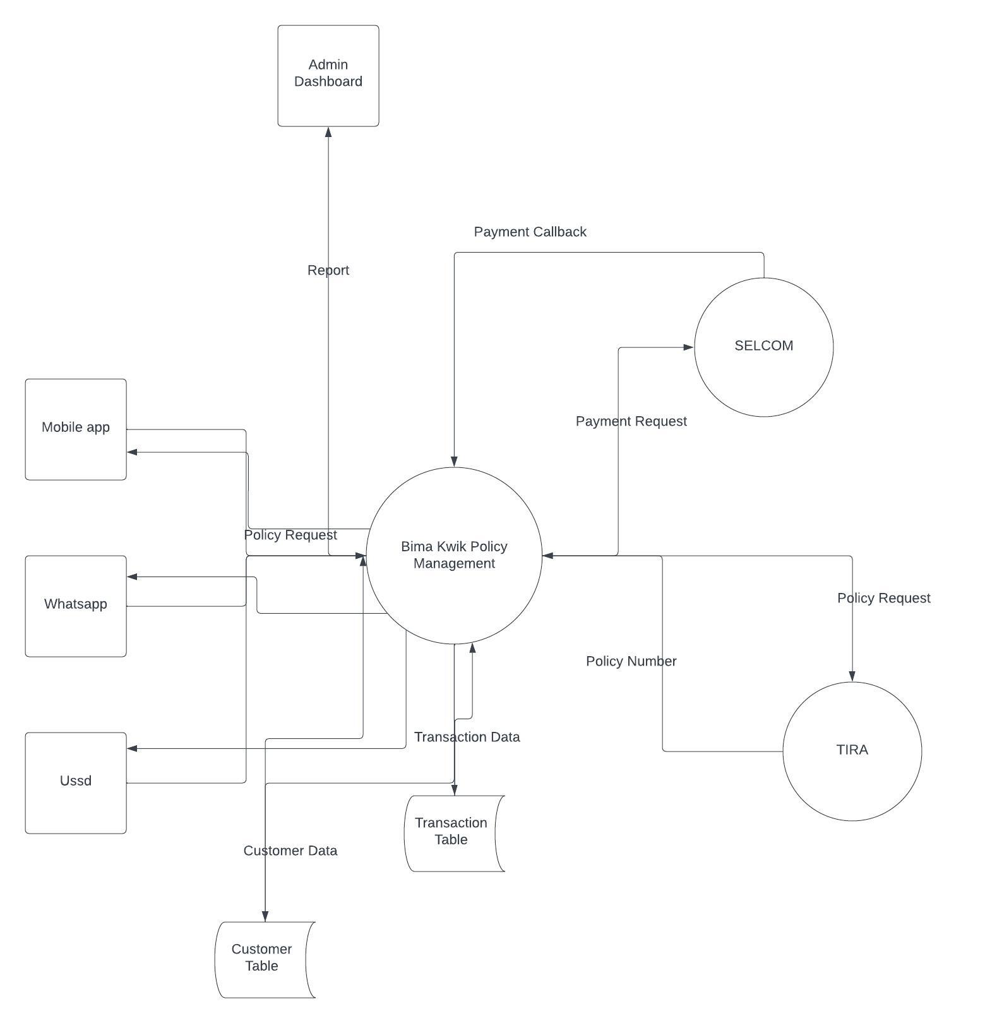

4. User Roles and Responsibilities

4.1 Sales Agent
Utilizes the mobile app and WhatsApp bot to engage customers and facilitate insurance sales.
Manages customer inquiries and provides assistance throughout the purchasing process.

4.2 Admin
Monitors and manages transactions, interactions, and user accounts through the intuitive admin dashboard.

4.3 Insurance Companies
Approves sales agents and manages claims resolution.
Designs and creates insurance packages available for sales agents.
Manages interactions related to policies and claims.

4.4 TIRA (Tanzania Insurance Regulatory Authority)
Ensures adherence to regulatory standards by auditing the platform's policies and data.

5. Data Management

5.1 Database Architecture
The system utilizes a relational database to facilitate efficient data storage, management, and retrieval.

5.2 Data Models
User Data Model: Stores user information, authentication data, and preferences.
Sales Records Model: Tracks sales transactions, policies purchased, and associated payment details.
Claims Data Model: Manages claim information, statuses, and communication with insurance companies.
Package Information Model: Stores details about available insurance packages.
Regulatory Compliance Data Model: Stores data relevant to regulatory requirements and audits.

5.3 TIRA Integration
Policies and associated information are automatically shared with TIRA's systems to meet regulatory obligations.

6. Security and Authentication

6.1 User Authentication and Authorization
Secure authentication mechanisms verify users' identities during login.
Role-based access control ensures that users can access only the functionalities they are authorized for.

6.2 Encryption and Data Security
Sensitive data, including personal information and payment details, are encrypted during transmission and storage to ensure data security.

6.3 Role-Based Access Control
Users are assigned specific roles that determine their access to different platform features and data.

7. Payment Integration

7.1 Selcom Integration
The platform integrates Selcom's payment gateway APIs to provide users with a seamless and secure mobile money payment option.

7.2 Payment Processing Flow
User selects an insurance package and initiates payment.
The platform sends a payment request to Selcom for processing.
Selcom processes the payment and confirms it.
The platform updates the payment status and generates the policy.

8. User Interfaces

8.1 Mobile App
The intuitive mobile app allows users to explore insurance packages, complete purchases, and access policy details.

8.2 WhatsApp Bot
The interactive WhatsApp bot guides users through insurance purchasing, policy inquiries, and customer support.

8.3 Admin Dashboard
The comprehensive admin dashboard provides administrators with a centralized view of transactions, interactions, user management, and platform performance.

9. Business Logic and Processing

9.1 Sales Process
Sales agents use the mobile app or WhatsApp bot to present insurance packages to customers.
Users select a desired package and complete the payment process.
The platform verifies the payment status and generates policy details for the user.

9.2 Claims Handling
Users initiate claims through the platform, specifying relevant details.
Claims module facilitates communication between users, sales agents, and insurance companies.
Insurance companies review claims, determine their validity, and update the claim status accordingly.

9.3 Package Management
Insurance companies create, modify, and submit insurance packages for approval.
Approved packages are made available to sales agents for presentation to customers.

10. System Integration

10.1 API Communication
Microservices communicate seamlessly through well-defined APIs, ensuring consistent and reliable data exchange.

10.2 Integration with Insurance Companies
The platform integrates with insurance company systems to synchronize information about packages, claims, approvals, and agent interactions.

10.3 TIRA Integration
The platform's integration with TIRA systems facilitates policy sharing and auditing to ensure compliance with regulatory standards.

11. Regulatory Compliance

11.1 TIRA Interaction
Integration with TIRA's systems ensures that policies are shared and audited as per regulatory requirements.

11.2 Policy Posting and Audit
Policies created on the platform are automatically posted to TIRA's database, satisfying regulatory audit obligations.

12. Scalability and Performance

12.1 Load Balancing
The system employs load balancing to distribute incoming user requests evenly across multiple servers, optimizing performance.

12.2 Caching Strategies
Caching mechanisms are employed to optimize data retrieval and enhance response times for frequently accessed information.

12.3 Monitoring and Optimization
Key performance metrics are continuously monitored to identify areas for optimization and ensure seamless operation during peak loads.

13. Deployment and Infrastructure

13.1 Cloud Hosting
The platform is hosted on cloud infrastructure, allowing for elasticity, scalability, and resilience.

13.2 DevOps Practices
Continuous integration and continuous deployment (CI/CD) practices enable efficient development, testing, and deployment processes.

14. Future Enhancements

14.1 Potential Features
Future enhancements may include personalized policy recommendations, advanced data analytics, and expanded insurance categories.

14.2 Scalability Planning
As the user base grows, the platform can be further scaled using additional resources and load distribution techniques.

15. Conclusion
The Bima Kwik Insurance Platform's architecture is meticulously designed to provide users with a convenient and secure way to purchase insurance policies. The integration of third-party services, collaboration with insurance companies, and adherence to regulatory standards ensure a seam
less and compliant experience for all users.

APPENDIX

BIMA KWIK MIND MAP

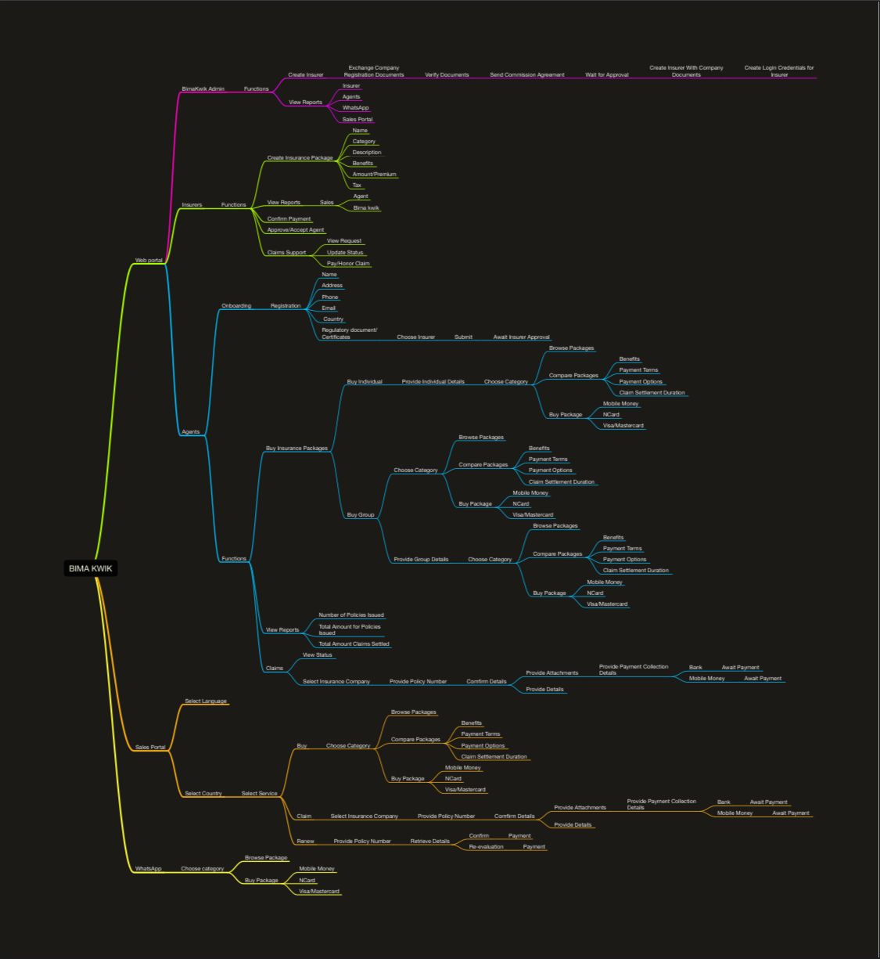

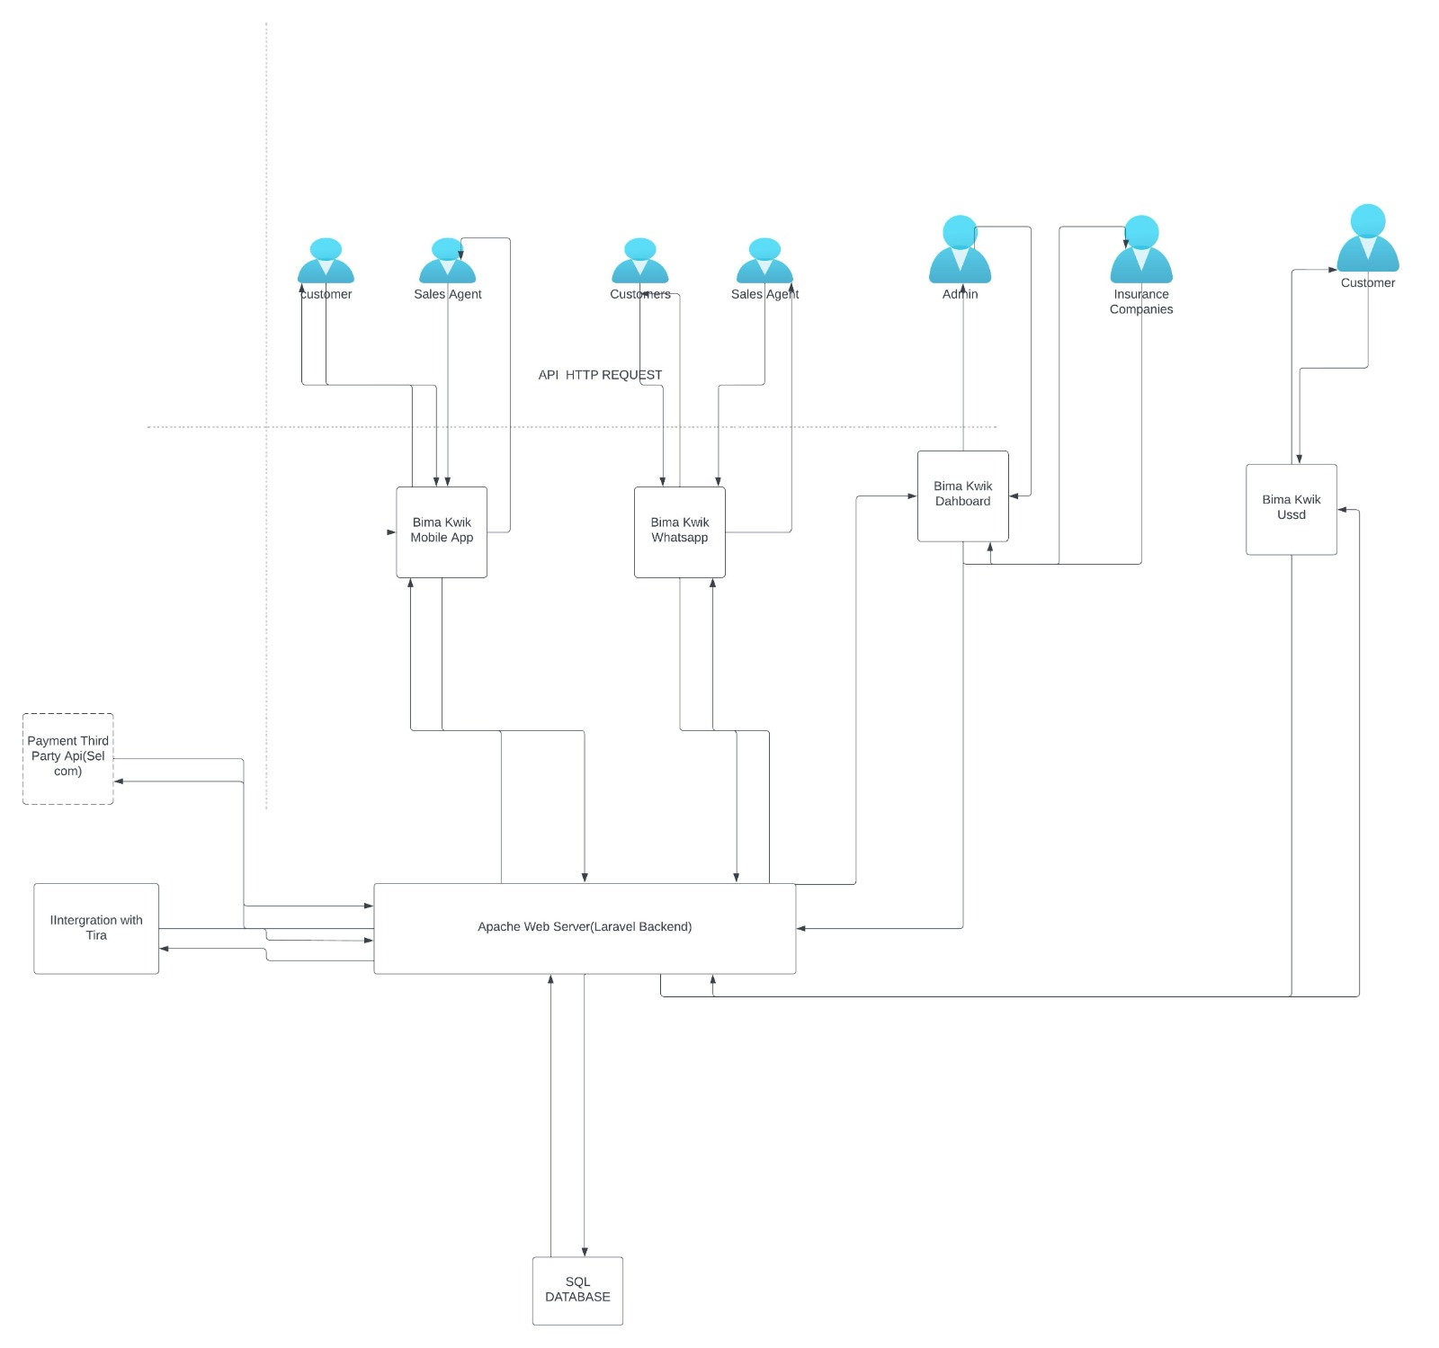
ARCHITECTURE DIAGRAM

